Alliance School of Advanced Computing

Course Name: Graph Analytics
Course Code: E1ITC 302
Assignment No: 5

Name of the Student: NAVYA S

Registration Number: 2411021060373

A. Title of The Problem:
Graph Analytics – University Course Registration System Using Neo4j
B. Problem Statement in details:
A university requires a graph database to manage information about students, faculty members, courses, and academic departments. The system must represent these entities as nodes and their associations as relationships using Neo4j. It should maintain student enrolments, faculty teaching assignments, student–department associations, and department–course associations with appropriate properties. Cypher queries must be used to create the graph, retrieve relevant information, filter records based on specific conditions, and verify nodes and relationships. The system should enable efficient querying and analysis of the university's course registration data.
C. Student’s Github link of report and code upload, along with the readme file: NAVYAS367/GA-module-5
D. Solution Steps/Algorithm:
- Launch Neo4j Desktop, create a local database named UniversityDB, and start the database.
- Use Cypher queries to create Student, Faculty, Course, and Department nodes with the appropriate properties.
- Establish the ENROLLED_IN, TEACHES, BELONGS_TO, and OFFERS relationships according to the specified directions.
- Add the required properties, including semesterEnrolled, grade, and academicYear, to the relevant relationships.
- Execute queries to visualize the graph, count nodes by label, and validate the relationship types and directions.
- Perform retrieval and filtering operations to obtain details about students, courses, faculty members, and departments.
- Examine the query results and take screenshots of the graph visualization and query outputs for the final assignment submission.

E. Quires:
1. Create all student, faculty, course, and department nodes with the given properties.
Query:

CREATE
// Student Nodes
(s1:Student {studentId: 'S101', name: 'Aarav Sharma', semester: 5, email: 'aarav@univ.edu'}),
(s2:Student {studentId: 'S102', name: 'Priya Das', semester: 5, email: 'priya@univ.edu'}),
(s3:Student {studentId: 'S103', name: 'Rahul Verma', semester: 3, email: 'rahul@univ.edu'}),
(s4:Student {studentId: 'S104', name: 'Sneha Roy', semester: 3, email: 'sneha@univ.edu'}),
(s5:Student {studentId: 'S105', name: 'Arjun Patel', semester: 5, email: 'arjun@univ.edu'}),

// Faculty Nodes
(f1:Faculty {facultyId: 'F101', name: 'Dr. Meera Sen', designation: 'Associate Professor', specialization: 'Database Systems'}),
(f2:Faculty {facultyId: 'F102', name: 'Dr. Amit Roy', designation: 'Assistant Professor', specialization: 'Data Analytics'}),

// Course Nodes
(c1:Course {courseCode: 'CS301', title: 'Graph Analytics', credits: 3, level: 'Advanced'}),
(c2:Course {courseCode: 'CS302', title: 'Database Management Systems', credits: 4, level: 'Core'}),
(c3:Course {courseCode: 'CS303', title: 'Data Mining', credits: 3, level: 'Advanced'}),
(c4:Course {courseCode: 'CS304', title: 'Big Data Analytics', credits: 4, level: 'Advanced'}),
(c5:Course {courseCode: 'CS305', title: 'NoSQL Databases', credits: 3, level: 'Core'}),

// Department Nodes
(d1:Department {departmentId: 'D101', name: 'Computer Science', building: 'Block A'}),
(d2:Department {departmentId: 'D102', name: 'Information Technology', building: 'Block B'});

Output:
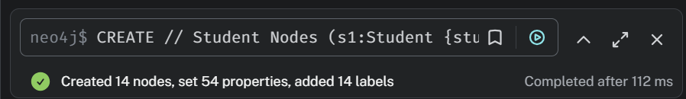
2. Create all the specified relationships with their appropriate directions.
// 1. Student -> Course (ENROLLED_IN)
MATCH (s:Student), (c:Course)
WHERE
(s.studentId = 'S101' AND c.courseCode IN ['CS301','CS302','CS305'])
OR (s.studentId = 'S102' AND c.courseCode IN ['CS301','CS303'])
OR (s.studentId = 'S103' AND c.courseCode IN ['CS302','CS304'])
OR (s.studentId = 'S104' AND c.courseCode IN ['CS303','CS305'])
OR (s.studentId = 'S105' AND c.courseCode IN ['CS301','CS304'])
CREATE (s)-[:ENROLLED_IN]->(c);

// 2. Faculty -> Course (TEACHES)
MATCH (f:Faculty), (c:Course)
WHERE
(f.facultyId = 'F101' AND c.courseCode IN ['CS302','CS305'])
OR (f.facultyId = 'F102' AND c.courseCode IN ['CS301','CS303','CS304'])
CREATE (f)-[:TEACHES]->(c);

// 3. Student -> Department (BELONGS_TO)
MATCH (s:Student), (d:Department)
WHERE
(s.studentId IN ['S101','S102','S103']
AND d.departmentId = 'D101')
OR
(s.studentId IN ['S104','S105']

AND d.departmentId = 'D102')
CREATE (s)-[:BELONGS_TO]->(d);

// 4. Department -> Course (OFFERS)
MATCH (d:Department), (c:Course)
WHERE
(d.departmentId = 'D101'
AND c.courseCode IN ['CS302','CS303','CS305'])
OR
(d.departmentId = 'D102'
AND c.courseCode IN ['CS301','CS304'])
CREATE (d)-[:OFFERS]->(c);
Output:
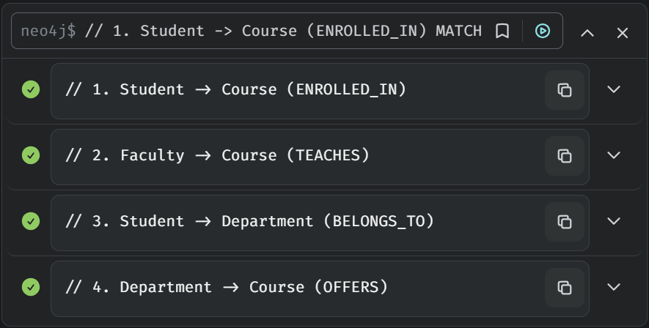
3. Assign properties to the ENROLLED_IN and TEACHES relationships.
Query:
A.ENROLLED_IN:
MATCH (s:Student)-[r:ENROLLED_IN]->(c:Course)
SET r.semesterEnrolled = s.semester,

r.grade = 'Not Published'
RETURN s.name AS Student,
c.title AS Course,
r.semesterEnrolled AS SemesterEnrolled,
r.grade AS Grade;
Output:
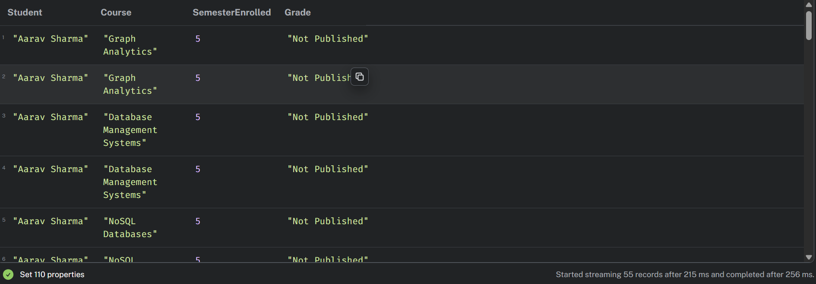
B. Teaches relationship:
Query:
MATCH (f:Faculty)-[r:TEACHES]->(c:Course)
SET r.academicYear = '2026-27'
RETURN f.name AS Faculty,
c.title AS Course,
r.academicYear AS AcademicYear;
Output:
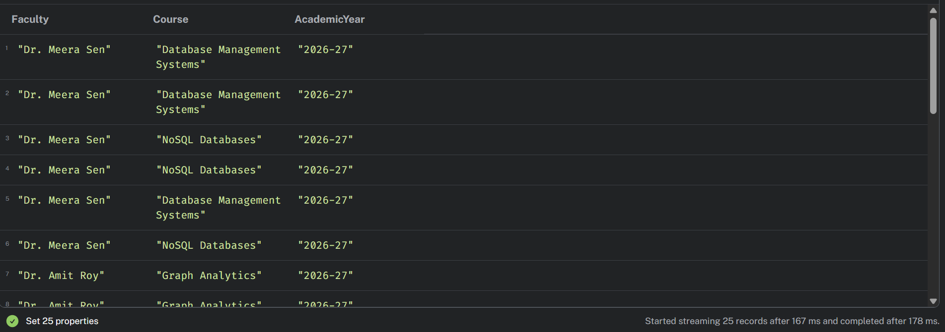

4. Display the complete graph.
Query:
MATCH (a)-[r]->(b)
RETURN a, r, b;
Output:
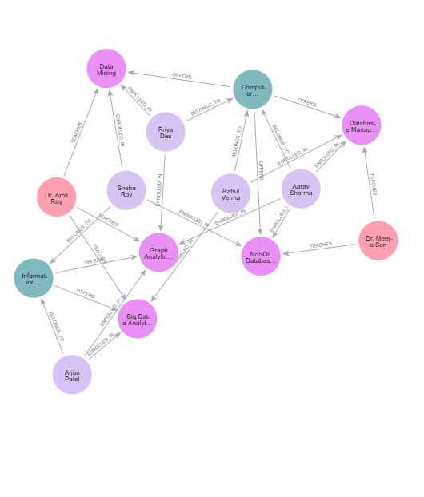

5. Count the number of nodes belonging to each label.
Query:
MATCH (n)
RETURN labels(n) AS NodeLabel,
count(n) AS TotalNodes
ORDER BY NodeLabel;

Output:
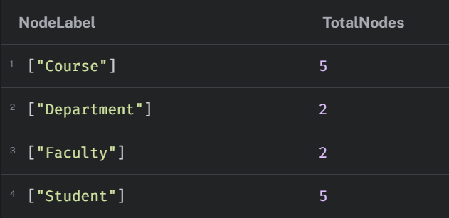
6. Display all relationship types and verify their directions.
Query:
MATCH (a)-[r]->(b)
RETURN labels(a) AS SourceLabel,
type(r) AS RelationshipType,
labels(b) AS TargetLabel,
count(r) AS TotalRelationships
ORDER BY RelationshipType;
Output:
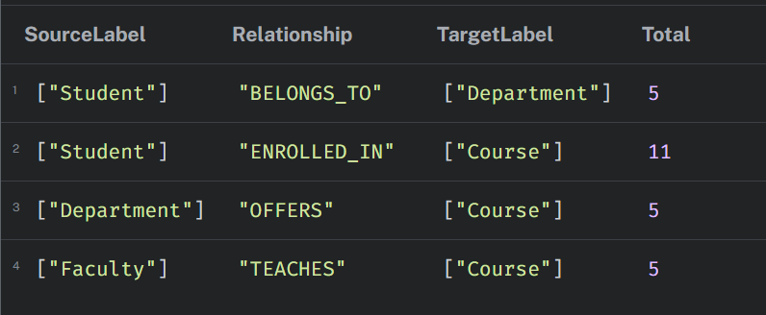

7. Retrieve all students studying in Semester 5
Query:
MATCH (s:Student)
WHERE s.semester = 5
RETURN s.studentId, s.name, s.semester, s.email;

Output:
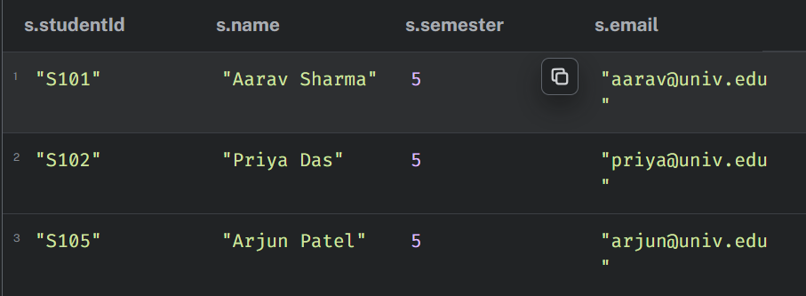
8. Find all courses with more than 3 credits.
Query:
MATCH (c:Course)
WHERE c.credits > 3
RETURN c.courseCode, c.title, c.credits;
Output:
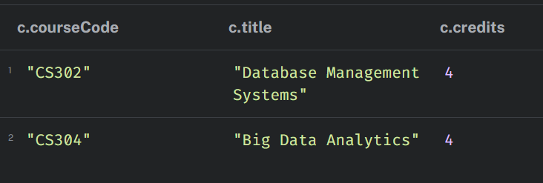
9. Retrieve the courses taught by Dr. Meera Sen
Query:
MATCH (f:Faculty {name: 'Dr. Meera Sen'})
-[r:TEACHES]->(c:Course)
RETURN f.name AS Faculty, c.title AS Course,
r.academicYear AS AcademicYear;

Output:
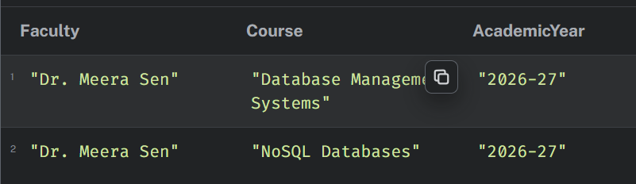
10. Find all students enrolled in Graph Analytics.
Query:
MATCH (s:Student)-[r:ENROLLED_IN]->
(c:Course {title: 'Graph Analytics'})
RETURN s.name AS Student,
r.semesterEnrolled AS Semester,
r.grade AS Grade;
Output:
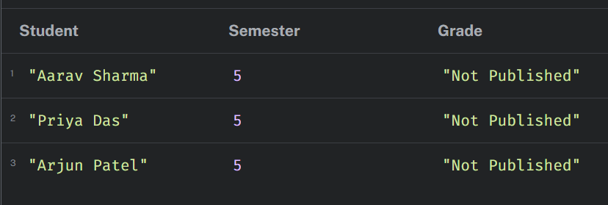
11. Display the names of all students belonging to the Computer Science department.
Query:
MATCH (s:Student)-[:BELONGS_TO]->
(d:Department {name: 'Computer Science'})
RETURN s.name AS Student, d.name AS Department;

Output:
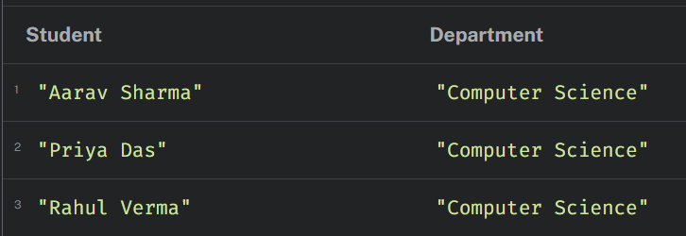
12. Find all courses offered by the Information Technology department.
Query:
MATCH (d:Department {name: 'Information Technology'})
-[:OFFERS]->(c:Course)
RETURN d.name AS Department, c.courseCode, c.title;
Output:
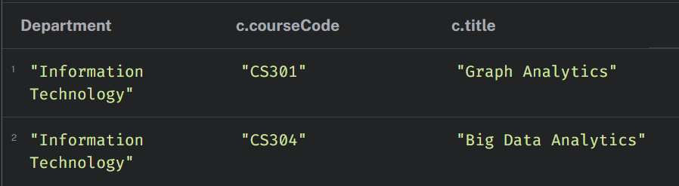
13. Retrieve all students enrolled in NoSQL Databases along with their semester and grade.
Query:
MATCH (s:Student)-[r:ENROLLED_IN]->
(c:Course {title: 'NoSQL Databases'})
RETURN s.name AS Student,
s.semester AS CurrentSemester,
r.semesterEnrolled AS SemesterEnrolled,
r.grade AS Grade;

Output:
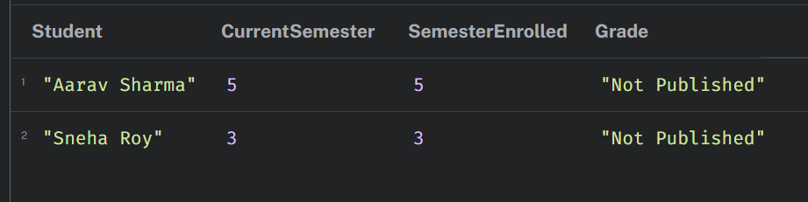
14. Find all students enrolled in both Graph Analytics and another course.
Query:
MATCH (s:Student)-[:ENROLLED_IN]->
(g:Course {title: 'Graph Analytics'}),
(s)-[:ENROLLED_IN]->(other:Course)
WHERE other <> g
RETURN s.name AS Student,
collect(DISTINCT other.title) AS OtherCourses;
Output:
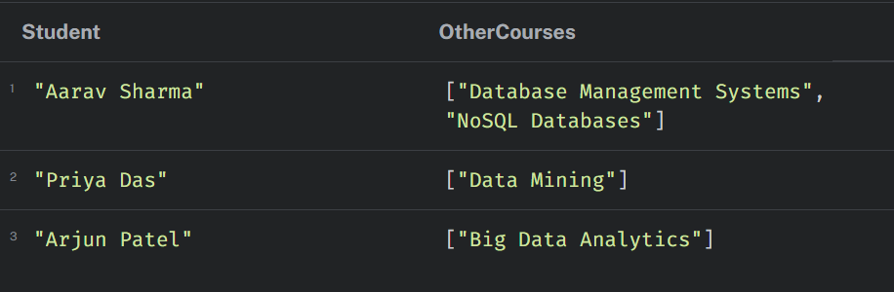
F.Conclusion:
Neo4j Desktop and the Cipher query language were used to successfully create the University Course Registration System. Nodes for students, professors, courses, and departments were constructed with the necessary attributes, and all interactions were formed with the relevant instructions. The TEACHES and ENROLLED_IN connections were given properties. Information about student enrollment, faculty teaching assignments, courses, and departments was retrieved and filtered using a variety of Cipher queries. The assignment shows how to effectively model, manage, and analyze linked university data using graph databases.

